**4CS Rental Product Demo**

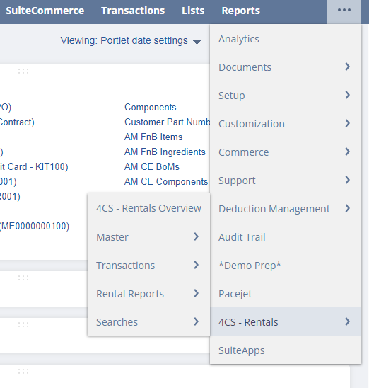

* Functionality Overview for 4CS Rental Product Demo:
  + **Rental Configuration:** This feature enables users to set up preferred forms for different Entity and Transaction records, ensuring a tailored and efficient rental management experience.
  + **Master Records:** In this category, users can access and manage all Master records related to the Rental product. This includes details such as Rental Item, Rental Item Contract, Rental Item Master, Re-rent sales order, and more.
  + **Transactions:** This section provides quick links to create various transactions essential for the rental business. Users can seamlessly generate Estimates, Sales Orders, Invoices, Purchase Orders, and Vendor Bills to streamline their operations.
  + **Rental Reports:** Custom reports designed specifically for the rental business are available in this category. These reports offer valuable insights and analytics, empowering users to make informed decisions and optimize their rental processes.
  + **Searches:** Custom searches tailored for the rental business are housed in this section. These searches enhance the efficiency of locating and retrieving relevant information, contributing to a more streamlined and responsive rental management system.

**Rental Item Record –**

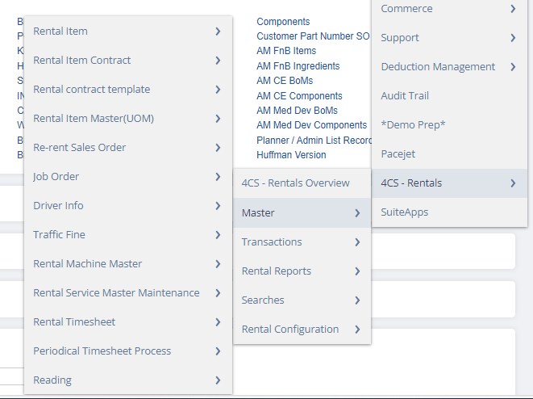

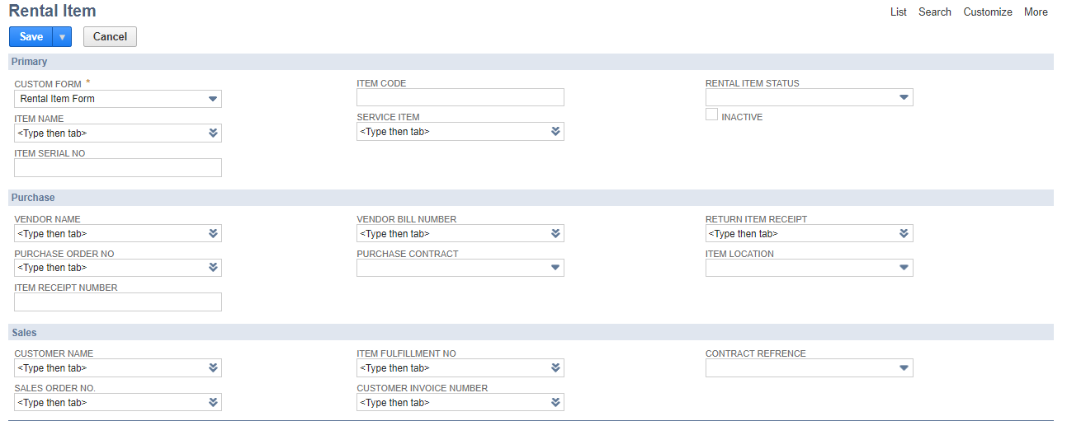

* Functionality Overview:

This custom record encapsulates comprehensive details about a serialized inventory item designated for rental purposes. The record seamlessly progresses through various stages, automatically updating pertinent information:

**1. Item Details:** The record initiates by capturing and maintaining detailed information about the serialized inventory item, ensuring a comprehensive overview of its specifications and characteristics.

**2. Purchase Transactions:** As the item progresses through the procurement process, the record automatically updates to reflect data from the Purchase transaction. This includes crucial details such as Vendor Name, Vendor Bill information, and the Item Receipt number, ensuring accurate documentation of the acquisition process.

**3. Sales Transactions:** The record further evolves to encompass data from sales transactions. This involves capturing information like Customer Name, Sales Order Number, Item Fulfillment Number, and Customer Invoice Number. This ensures a complete and seamless traceability of the rental item from procurement to customer delivery and invoicing.

This integrated and automated approach enhances efficiency and accuracy in managing serialized inventory items designated for rental, providing a transparent and traceable record throughout the entire lifecycle of the product.

**\*\*Creation of Rental Service Item through Serialized Inventory Item\*\***

**Scenario:**

When a Serialized Inventory Item is created, and the "AVAILABLE FOR RENT" checkbox is marked as true, the system will automatically generate a corresponding Rental Service Item. This process streamlines the creation of service items specifically tailored for rental, enhancing efficiency and accuracy in managing rental inventory.

**Process Flow:**

**1. Serialized Inventory Item Creation:**

* The process begins with the creation of a Serialized Inventory Item in the system.
* Essential details such as item specifications, identification, and availability status are configured during this step.

**2. Availability Check:**

* A key criterion for the creation of a Rental Service Item is the status of the "AVAILABLE FOR RENT" checkbox associated with the Serialized Inventory Item.
* If the checkbox is marked as true, indicating the item's availability for rental, the system proceeds to the next step.

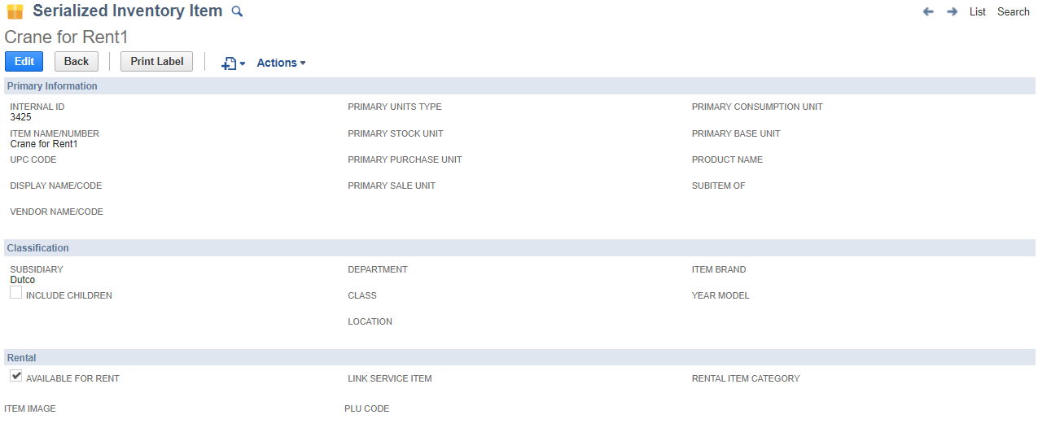

**3. Rental Service Item Creation:**

* Upon confirming the availability, the system automatically generates a corresponding Rental Service Item.
* The Rental Service Item inherits relevant details from the Serialized Inventory Item, ensuring consistency and coherence in the rental management system.

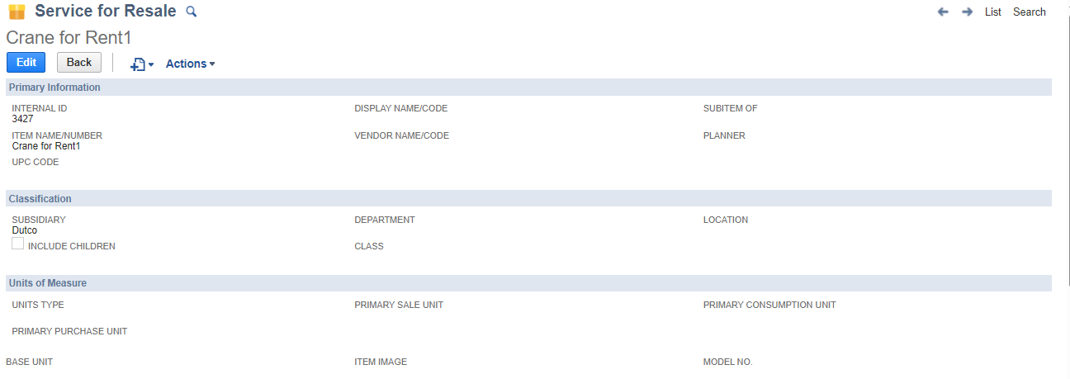

**4. Linking the Rental Service Item:**

* + The Rental Service Item is seamlessly linked to the Serialized Inventory Item, establishing a clear association between the physical item and its corresponding service representation.
* By implementing this use case, organizations can effortlessly manage and track rental services associated with Serialized Inventory Items, promoting a streamlined and automated approach to rental inventory management.

Functionality Process Flow for Rental Item Management:

**1. Purchase Order Creation**: The process commences with the creation of a Purchase Order (PO) specifically for a serialized inventory item intended for rental purposes. This PO serves as the initiation of the procurement process for the rental item.

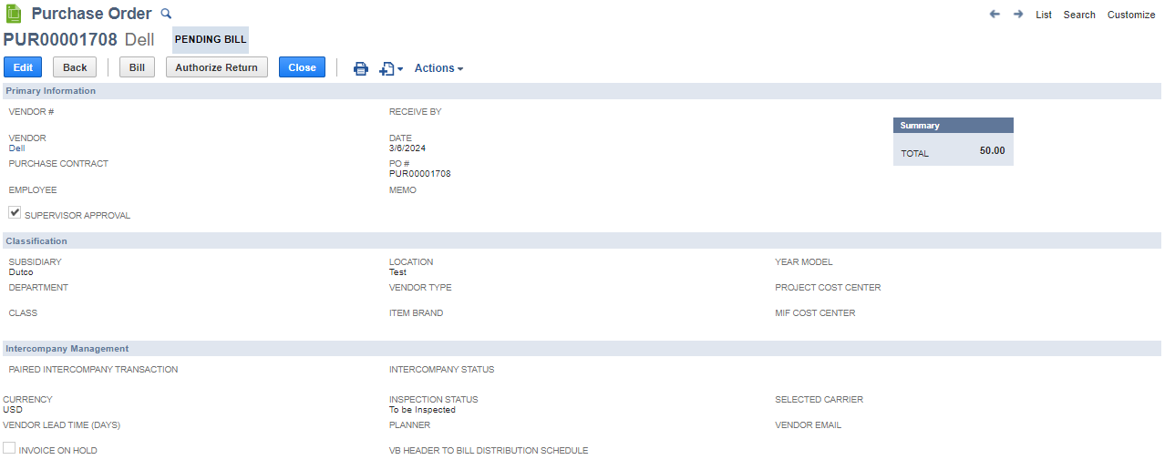

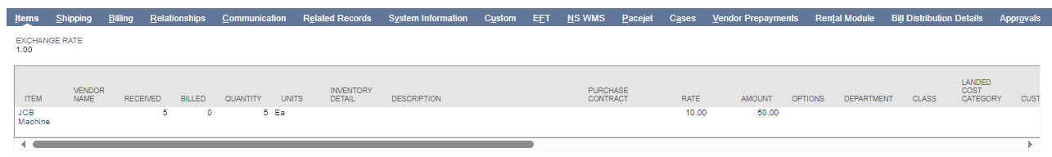

**2. Item Receipt Generation**: Following the creation of the PO, an Item Receipt is generated to formally acknowledge the physical receipt of the serialized inventory item. This step ensures that the system is updated with the actual reception of the rental item into the inventory.

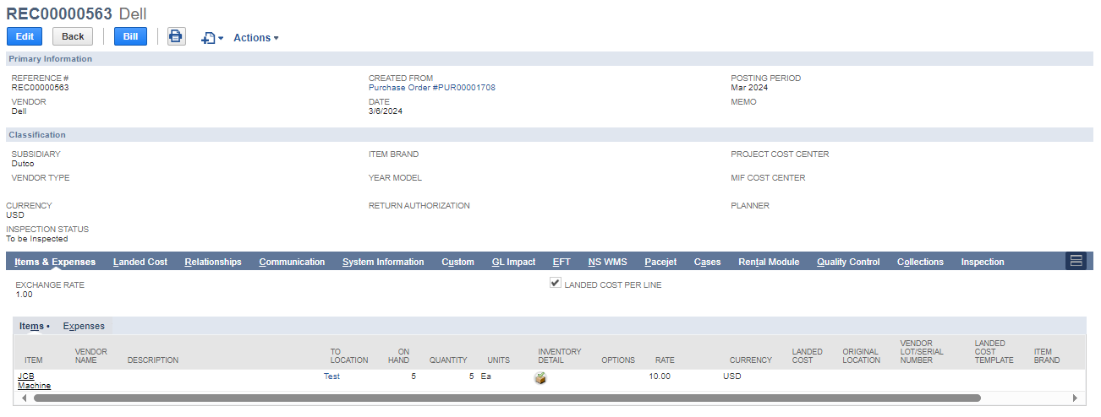

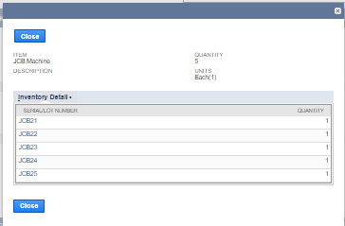

**3. Automatic Rental Item Record Creation:** Simultaneously with the Item Receipt, a Rental Item Record is automatically generated for each serialized item received. This record captures essential details about the rental item, establishing a dedicated record for effective management.

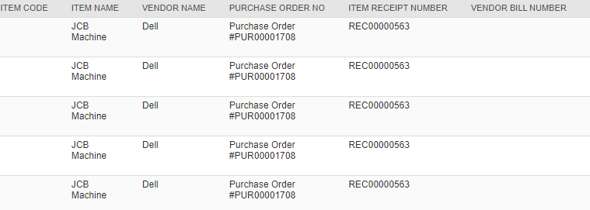

**4. Automatic Update of Rental Item Record**: The Rental Item Record is then automatically updated with the specific details from the Item Receipt. This seamless update process ensures that the Rental Item Record stays current and reflective of the latest information related to the procurement, such as Vendor Name, Item Receipt Number, and other relevant details.

